RABBIT SERVERS

Send email keeping in BCC
List-StatHub Announce <stathubann@csgi.com>; List-Global-SOC_Technicians List-Global-SOC_Technicians@csgi.com

Pre-Validations:
Open http://accprdisrsp0001.csgiprod.com:15672/#/
and http://accprdisrsp0002.csgiprod.com:15672/#/

*Go to Queues
*Click on +/- beside message rates
*go to overview and check consumer count
*Need to check messages (Ready Uacked and Total) should be zero
*While validating values in above URL and snapshot should be same.
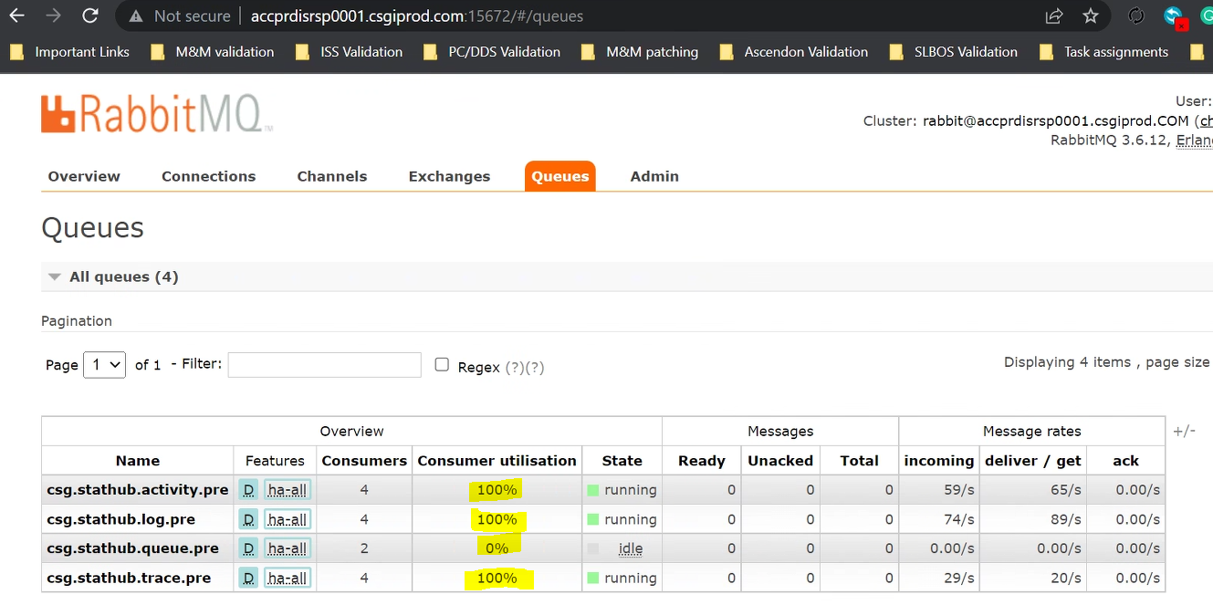

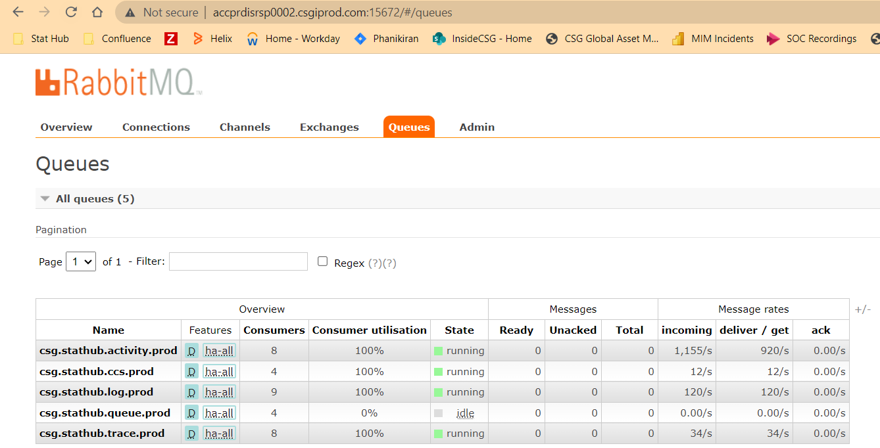

Validation:
Open PAM
Login to the server
Go to the task manager and check if any other user except you are logged in. If yes we need to inform the user.
Open software center inside the server and click on updates.
Install whatever is there and reboot once the installation is done (Just before rebooting please mention the same in the M&M channel)
crosscheck again after logging to the same server
When done send out the email.
Post-Validation – Follow the same steps as mentioned in the Pre-Validation.

_______________________________________________________________________________________________________________________________________

ProactiveNet
You will be performing POD on proactive net server- OMACSGITIMW01
Step 1 : Contact Custom Application support L3 and OSC Net Ops and tell them to disable the CVP.
Step 2 : Proactivenet application validation procedure - https://confluence.csgicorp.com/pages/viewpage.action?spaceKey=EM&title=ProactiveNet+Moving+to+Citrix

Step 3 : If pre-validations look good, log in to the server with Pam and check if anyone is connected. Tell the user before starting the patching work.
step 4: Open the software center and install the available patches. Then restart the server.
Step 5: Wait 5–10 minutes after reboot and log back to see if updates are installed properly.
Step 6 : Perform post-validation ( follow step 2) & If the app isn't loading, or down, check pw system status using cmd , processes not running at all are denoted by (!Not Running!) as shown below
CMD> enter pw system status (this will show the all proactivenet and it processes. All the processes should have values in it and nothing should be in not running state.

_______________________________________________________________________________________________________________________________________________________________________________________________________

Nightly Maintenance

Pre-validation

*Check the Pipeline Nightly-Maintenance-PROD-Green CVP is green.
http://aa2prdisjap0001.stathub-prod.csgiprod.com:8080/view/PROD/job/Nightly-Maintenance-PROD-Green/

*Check the nodes (Manage nodes and clouds) if Agent is connected in both the nodes(Maintenance-3 & Maintenance-4)
http://aa2prdisjap0001.stathub-prod.csgiprod.com:8080/computer/

*Open the Nightly maintenance servers in PAM.
Check if any other user has logged into those servers and please check with them before you start the patching.

*Open software center and install the patches available in updates.(Perform patching one server at a time)

*Reboot the server once all the updates are installed.(Perform patching one server at a time)

*Once again log into the servers and keep a check in the software center whether the updates are installed.
if not just sign out from the server and sign in once again.(Perform patching one server at a time)

Post-validation

*heck the nodes(Manage nodes and clouds) if Agent is connected in both the nodes(Maintenance-3 & Maintenance-4)
http://aa2prdisjap0001.stathub-prod.csgiprod.com:8080/computer/

